# **Steps to increase Kafka topic partitions in DC1 and DC2**

**Prerequisites**

* Log on as appadm
* Check that user has write access to /apps/kafka/kafka_2.11-0.10.0.1/bin
* Check that the Kafka and zookeeper are running

**DC1(PROD)::Steps**

**Step 1: Log in to HKLVAPAPP295(10.23.195.124)**

**Step 2: Run below commands to increase the partition for the topic content_cache.t, message_center.t, user_service_inbound.t and user_service_outbound.t**

1. /apps/kafka/kafka_2.11-0.10.0.1/bin/kafka-topics.sh --zookeeper localhost:2181 --alter --topic content_cache.t --partitions 3
2. /apps/kafka/kafka_2.11-0.10.0.1/bin/kafka-topics.sh --zookeeper localhost:2181 --alter --topic message_center.t --partitions 3
3. /apps/kafka/kafka_2.11-0.10.0.1/bin/kafka-topics.sh --zookeeper localhost:2181 --alter --topic user_service_inbound.t --partitions 3
4. /apps/kafka/kafka_2.11-0.10.0.1/bin/kafka-topics.sh --zookeeper localhost:2181 --alter --topic user_service_outbound.t --partitions 3

**Step 3: Verify the partition counts in HKLVAPAPP295(10.23.195.124), HKLVAPAPP296(10.23.195.126) and HKLVAPAPP314(10.23.195.169) using below command**

1. /apps/kafka/kafka_2.11-0.10.0.1/bin/kafka-topics.sh --describe --zookeeper localhost:2181 --topic content_cache.t
2. /apps/kafka/kafka_2.11-0.10.0.1/bin/kafka-topics.sh --describe --zookeeper localhost:2181 --topic message_center.t
3. /apps/kafka/kafka_2.11-0.10.0.1/bin/kafka-topics.sh --describe --zookeeper localhost:2181 --topic user_service_inbound.t
4. /apps/kafka/kafka_2.11-0.10.0.1/bin/kafka-topics.sh --describe --zookeeper localhost:2181 --topic user_service_outbound.t

**Note:-PartitionCount count should be 3 for all topics (content_cache.t, message_center.t, user_service_inbound.t and user_service_outbound.t) as shown in below image.**

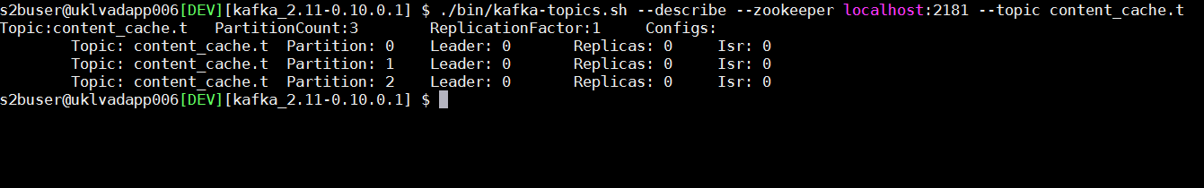

**DC2(DR):**

**Steps**

**Step 1: Log in to HKLVASAPP295 (10.23.195.125)**

**Step 2: Run below commands to increase the partitions for topic content_cache.t, message_center.t, user_service_inbound.t and user_service_outbound.t**

1. /apps/kafka/kafka_2.11-0.10.0.1/bin/kafka-topics.sh --zookeeper localhost:2181 --alter --topic content_cache.t --partitions 3
2. /apps/kafka/kafka_2.11-0.10.0.1/bin/kafka-topics.sh --zookeeper localhost:2181 --alter --topic message_center.t --partitions 3
3. /apps/kafka/kafka_2.11-0.10.0.1/bin/kafka-topics.sh --zookeeper localhost:2181 --alter --topic user_service_inbound.t --partitions 3
4. /apps/kafka/kafka_2.11-0.10.0.1/bin/kafka-topics.sh --zookeeper localhost:2181 --alter --topic user_service_outbound.t --partitions 3

**Step 3: Verify the partition counts in HKLVASAPP295(10.23.195.125)**, **HKLVASAPP296(10.23.195.127) and HKLVASAPP314(10.23.195.170) using below command**

1. /apps/kafka/kafka_2.11-0.10.0.1/bin/kafka-topics.sh --describe --zookeeper localhost:2181 --topic content_cache.t
2. /apps/kafka/kafka_2.11-0.10.0.1/bin/kafka-topics.sh --describe --zookeeper localhost:2181 --topic message_center.t
3. /apps/kafka/kafka_2.11-0.10.0.1/bin/kafka-topics.sh --describe --zookeeper localhost:2181 --topic user_service_inbound.t
4. /apps/kafka/kafka_2.11-0.10.0.1/bin/kafka-topics.sh --describe --zookeeper localhost:2181 --topic user_service_outbound.t

**Note: PartitionCount count should be 3 for all topics(content_cache.t, message_center.t, user_service_inbound.t and user_service_outbound.t) as shown in below image.**

